**AZURE FRONT DOOR:**

It is single global entry point for the application and it mainly handles http(s) requests.

If different services of an application are deployed in various regions and the client tries access these services from a region, azure front door allows the client to access these services from the nearest edge location or point of presence. It enables the client to access these services with low latency and high availability.

**IMPLEMENTATION OF AZURE FRONT DOOR:**

**Step1:** Deploy two web applications is two different regions. In this case, one web app is in Central India and the other is in West US 3.

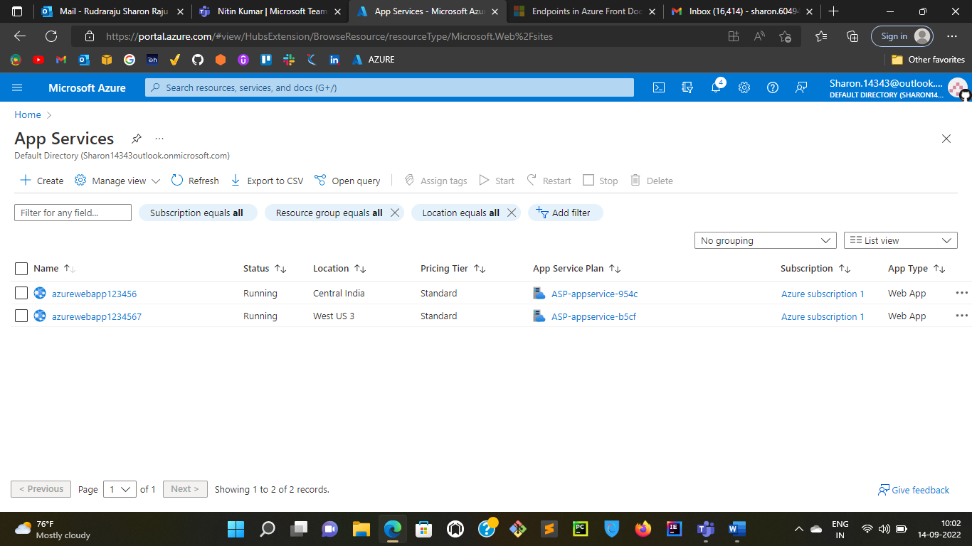

**Step2:** Create a front door service. In this case, I created with the name “azurefrontdoor”

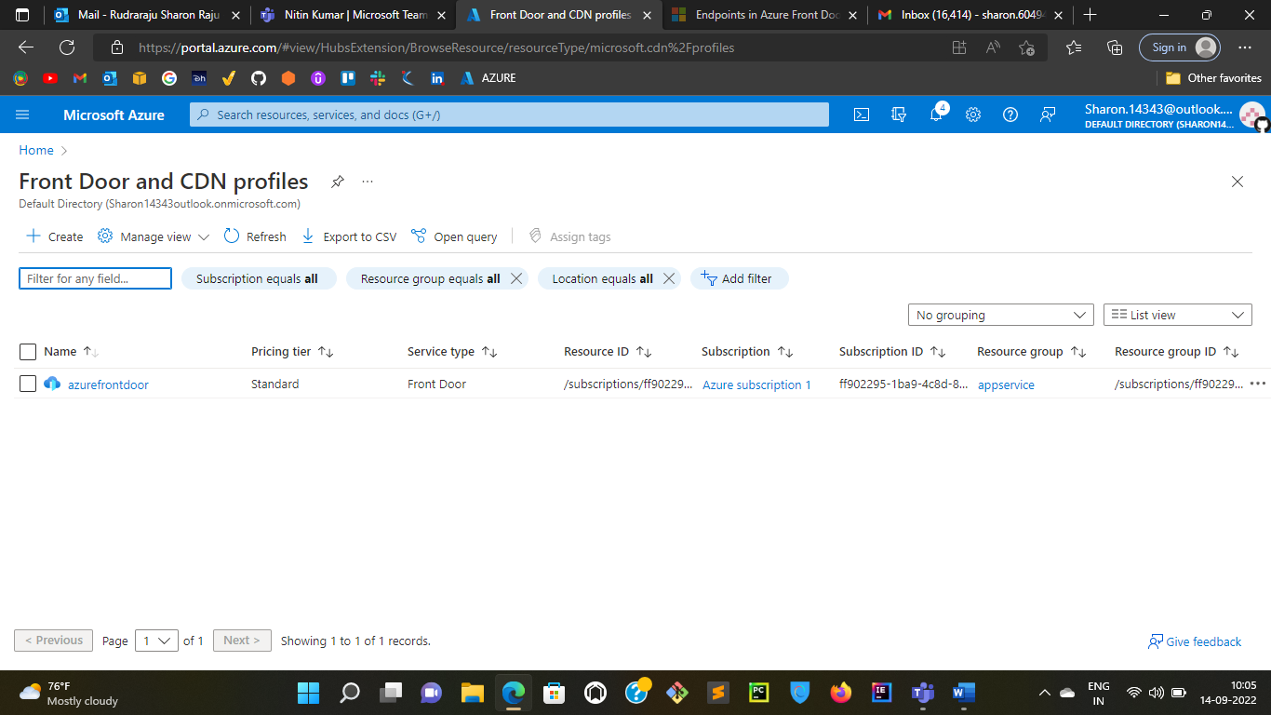

**Step3:** Create an endpoint hostname through which the users access the services of the application.

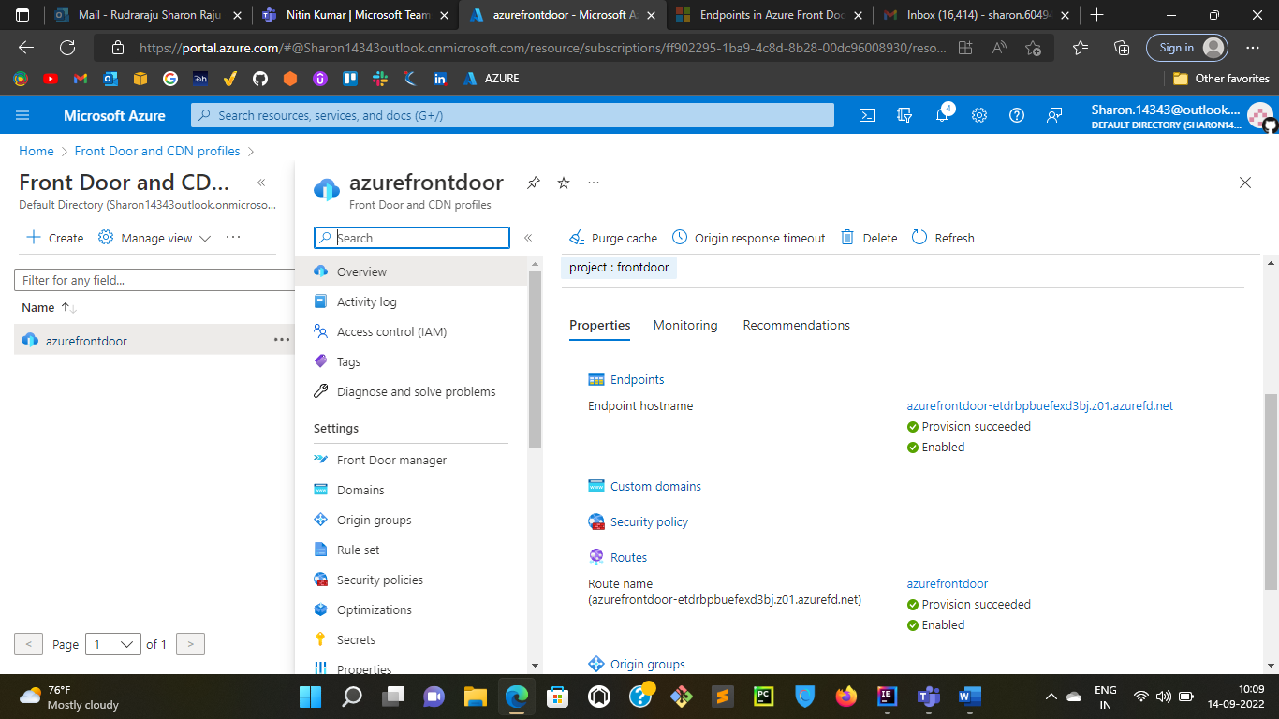

**Step4:** Update the origin group and add the available origin host names

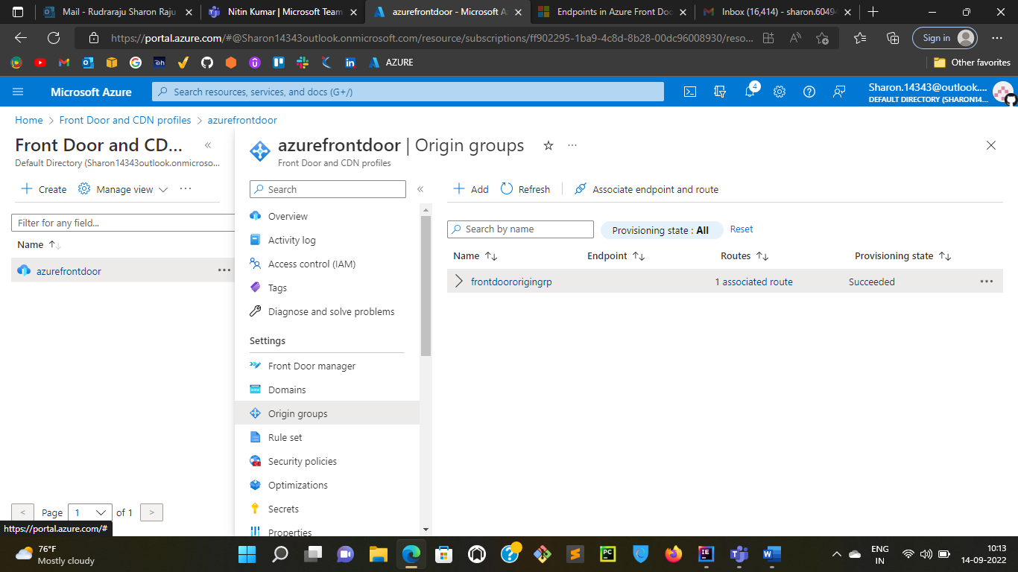

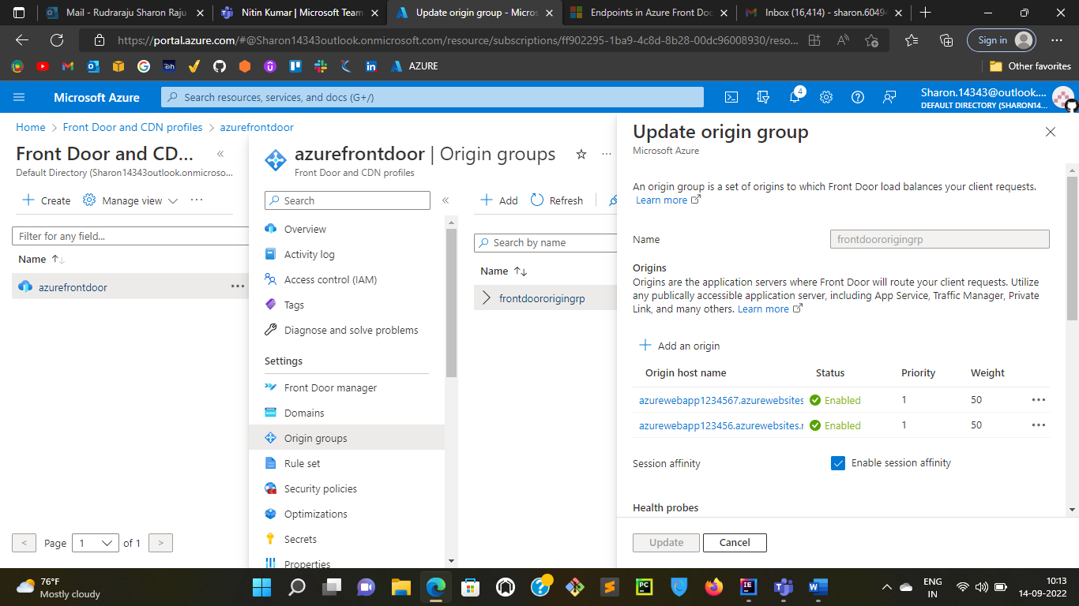

As there are two origin host names above, the traffic will be distributed between them. And if any one of them goes down the traffic will be routed to the other.